CAAS

At the beginning of the game, I was given access to a site called *COWSAY AS A SERVICE* .

On opening the link I was directed to a page as shown below,

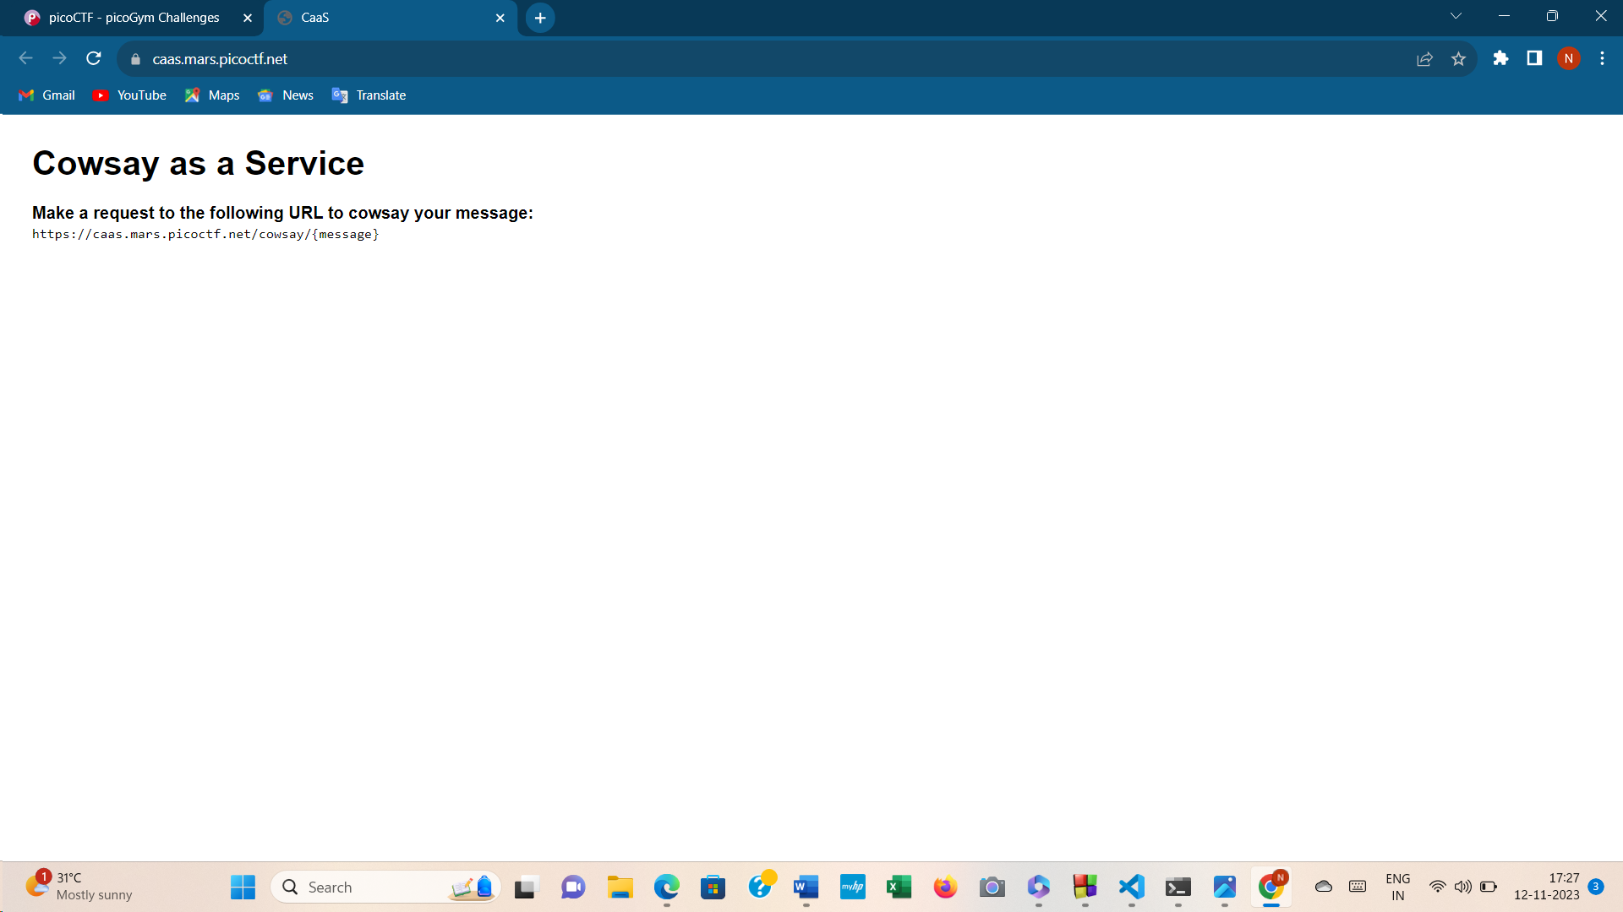

Copying the link address, I used visual studio code to understand the source code of the page. Since this deals with web exploitation I couldn’t find anything much useful. Then I googled web tools and installed *burp suite application* where I inspected the source code tried editing the message into some random name called *mooh* to check whether it .I found that it doesnot have any impacts on it Then I used cat command to retrieve the necessary data and finally captured the flag.

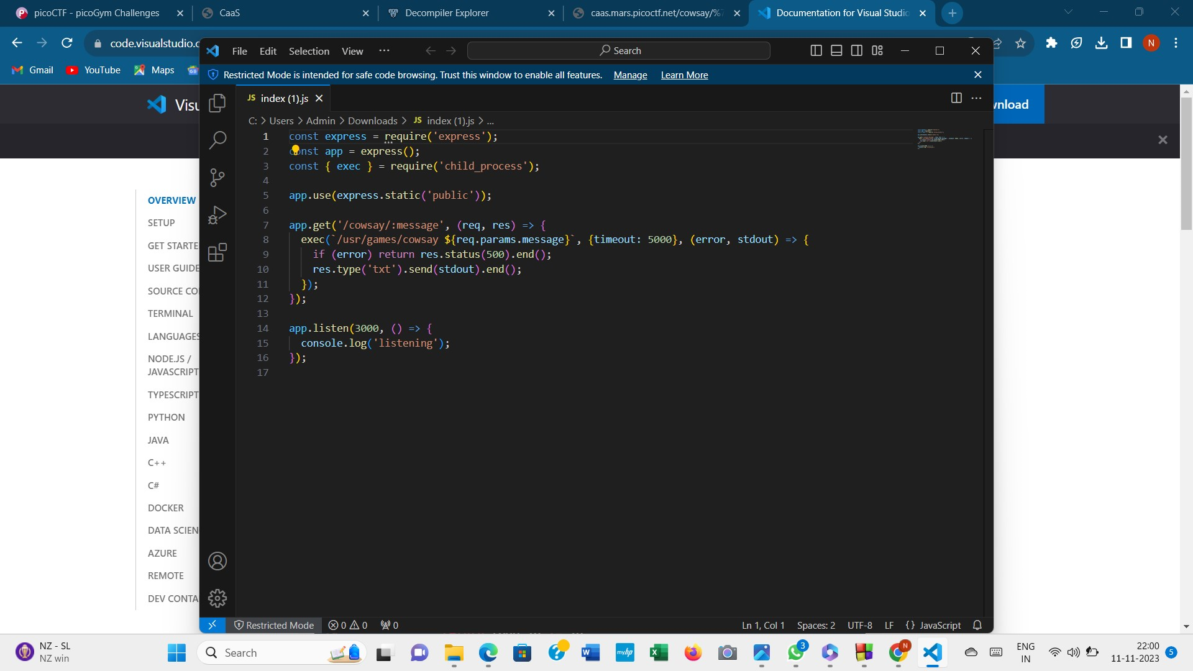

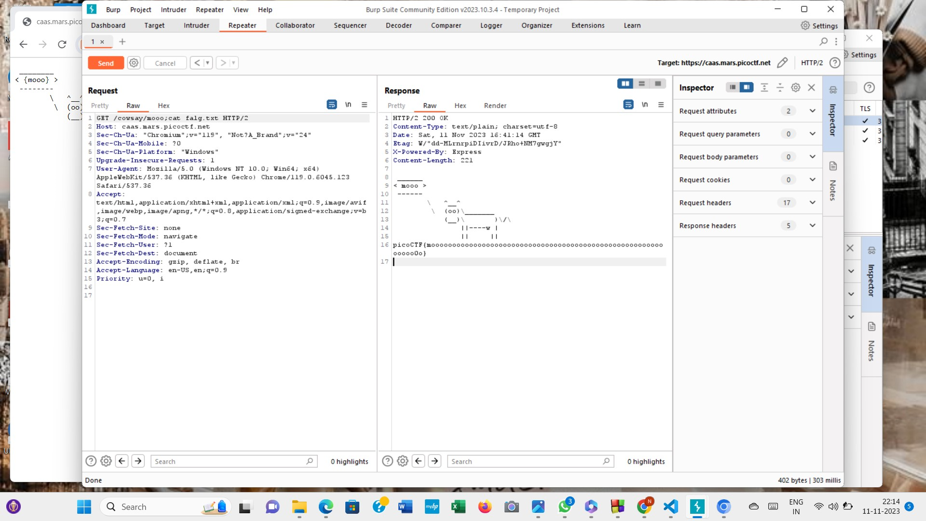

FORbiddden path

In this question we were given a kind of hint or idea about the game

“We know that the website files live in / usr/share/nginx/html/ and the flag is at /flag.txt but the website is filtering absolute file paths.” Using any kind of username didn’t provide us access to the site.

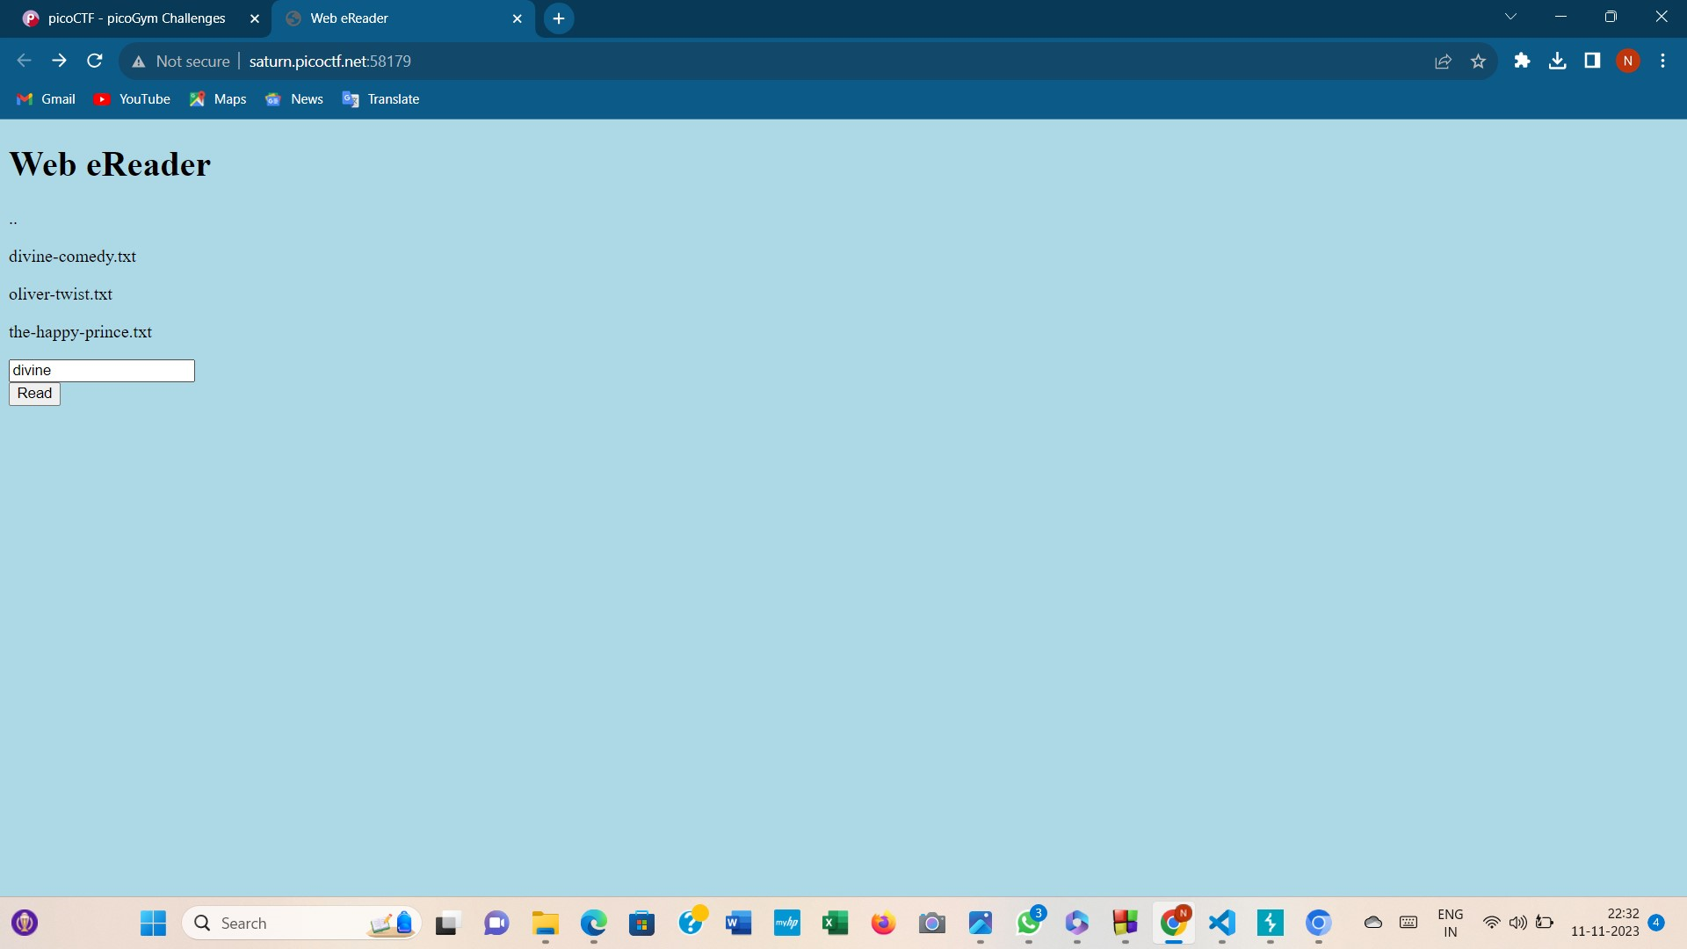

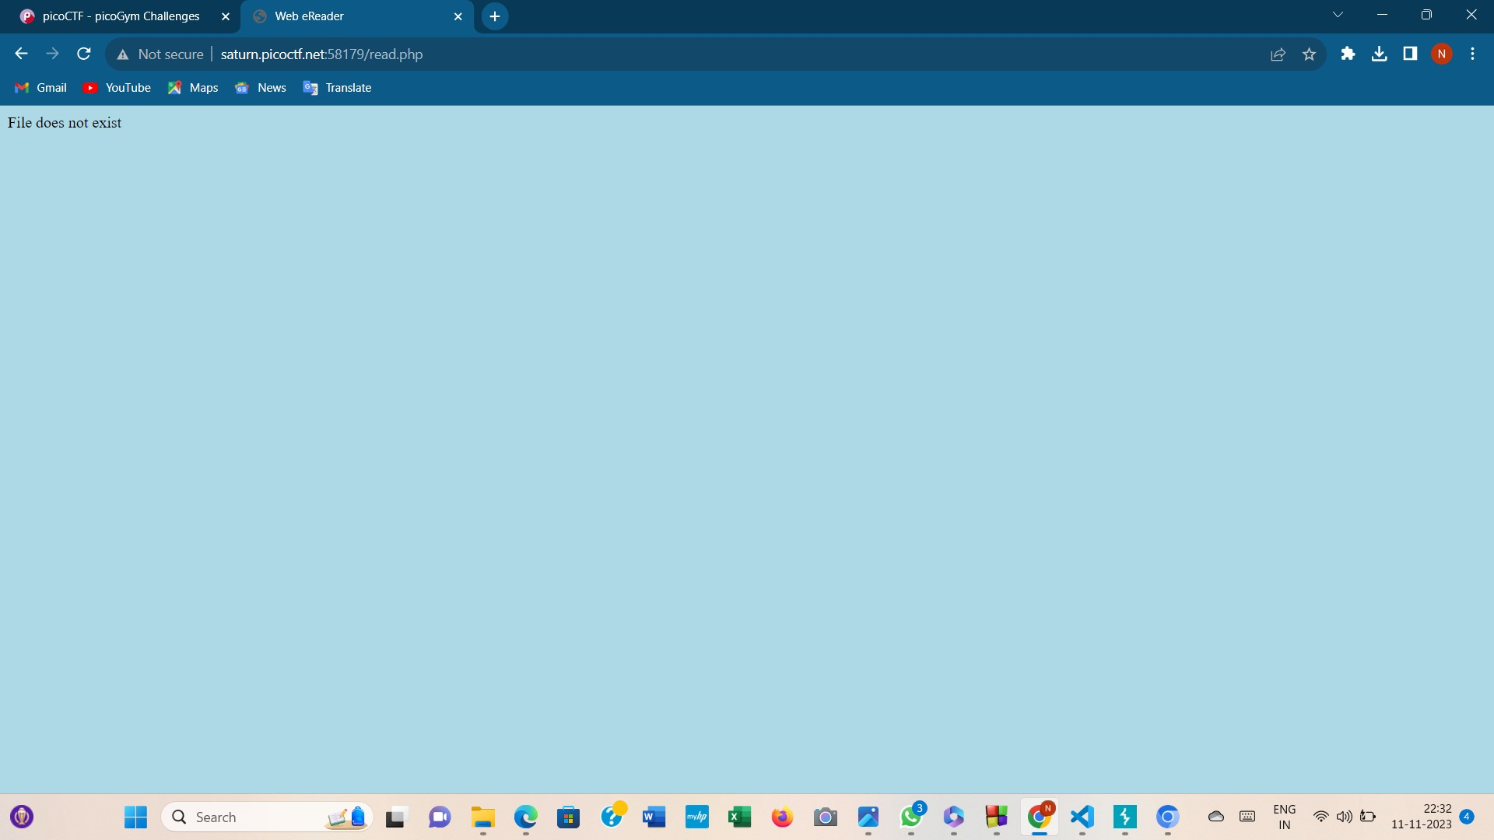

Finally using this username (given in the image below) gave access to the flag

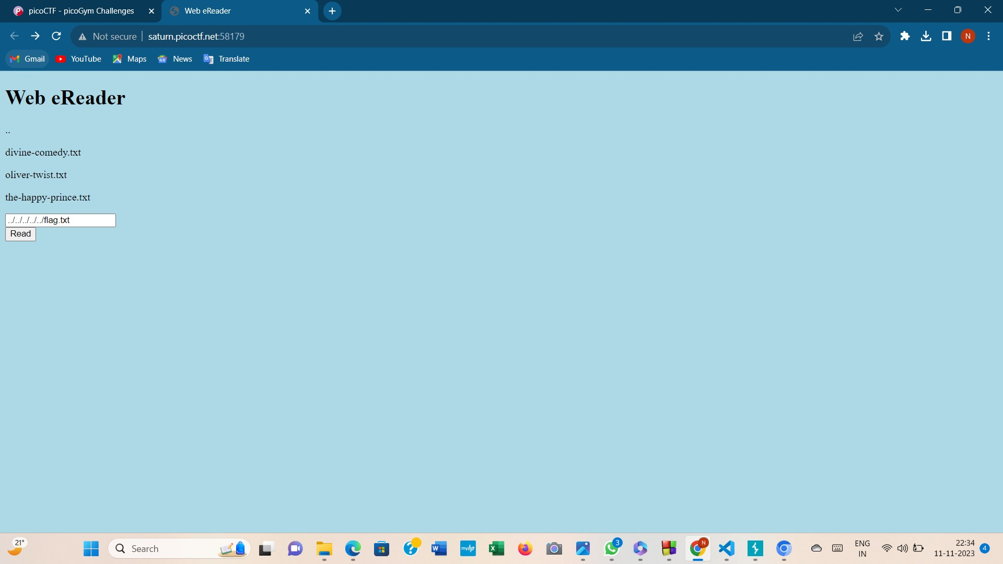

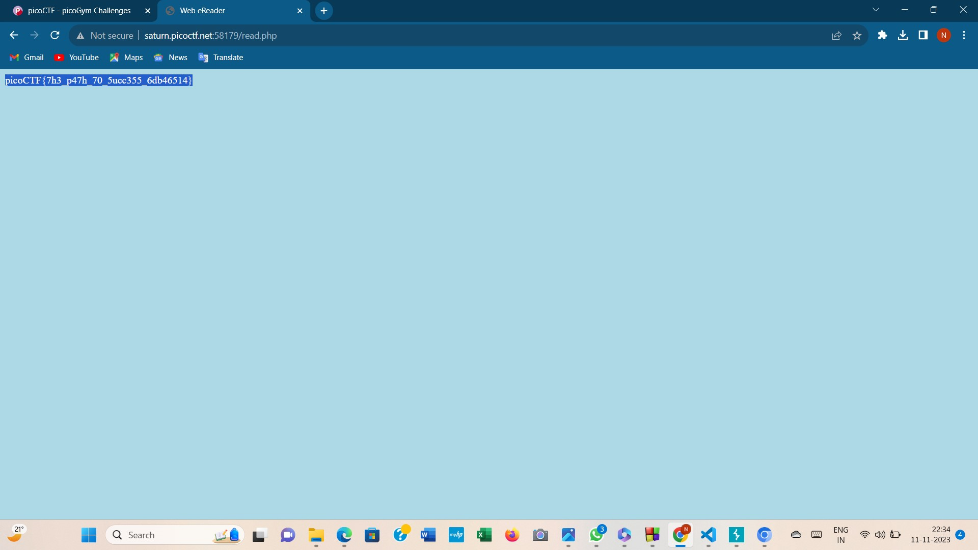

#### Tunn3l v1s10n

The description says that we have been provided with a file and hint says *that the data is weird and its wont display right.*

*So I opened the file on notepad and found it in some other format since it was a bitmap file .So isaved it using extension .bmp but I couldn’t load the image ;so once again I used hex editor( keeping in mind the bitmap format )I edited it and reloaded the image and I was able to see the code*

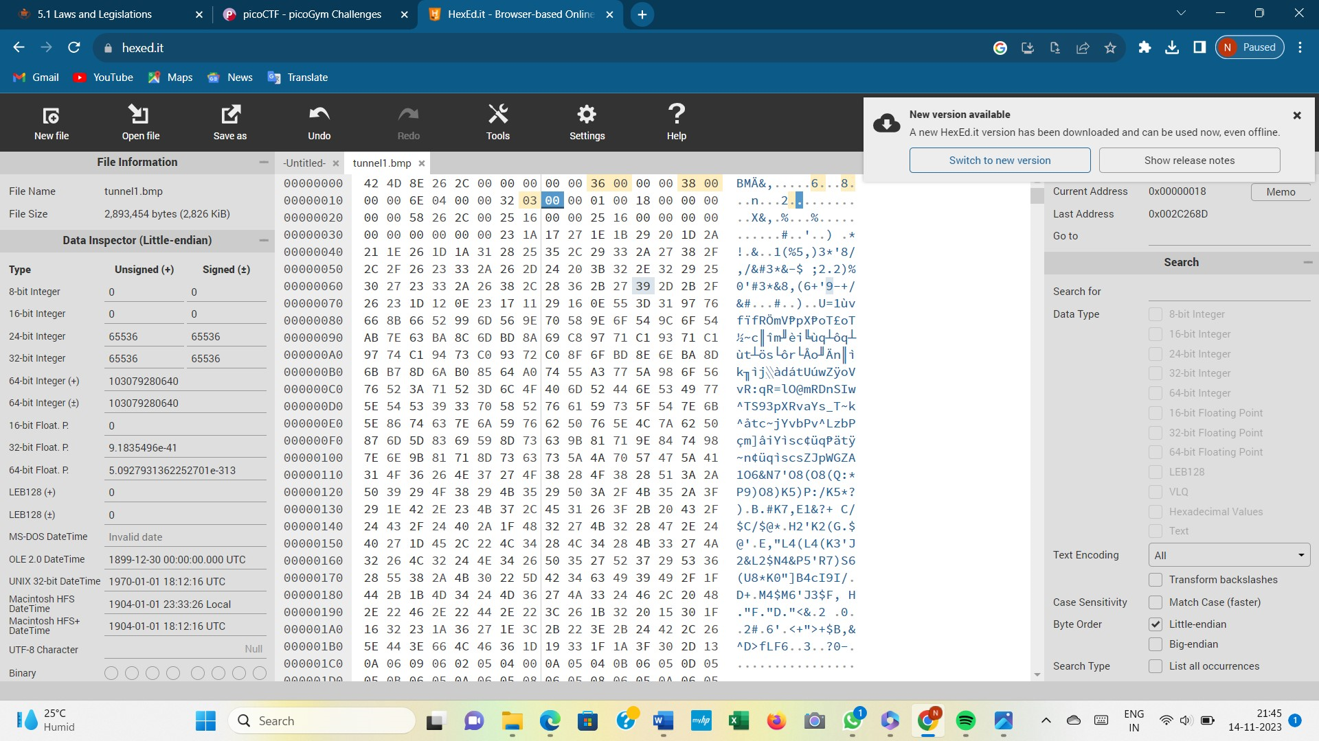

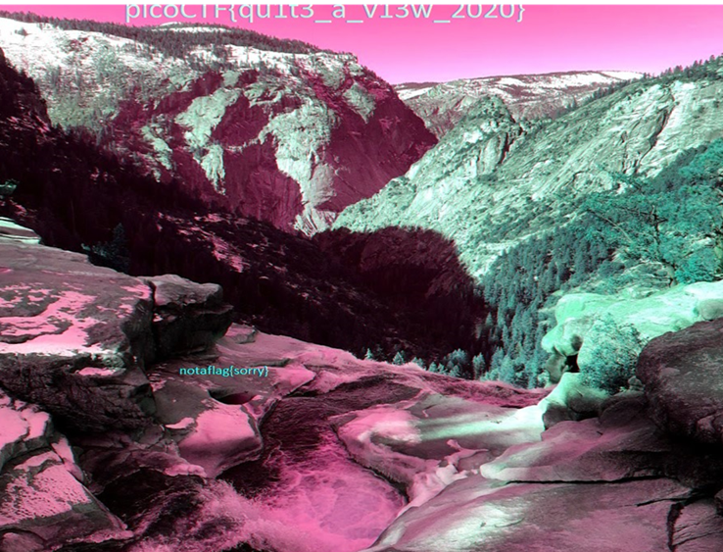

KEYGENME-PY

30 points keygenme -py was not that bad .Here we were given a code file.After going through the file I came across certain key texts; to recollect them I created a new python file on visual code and since I didn’t have compiler I used online and compiler and found the output.

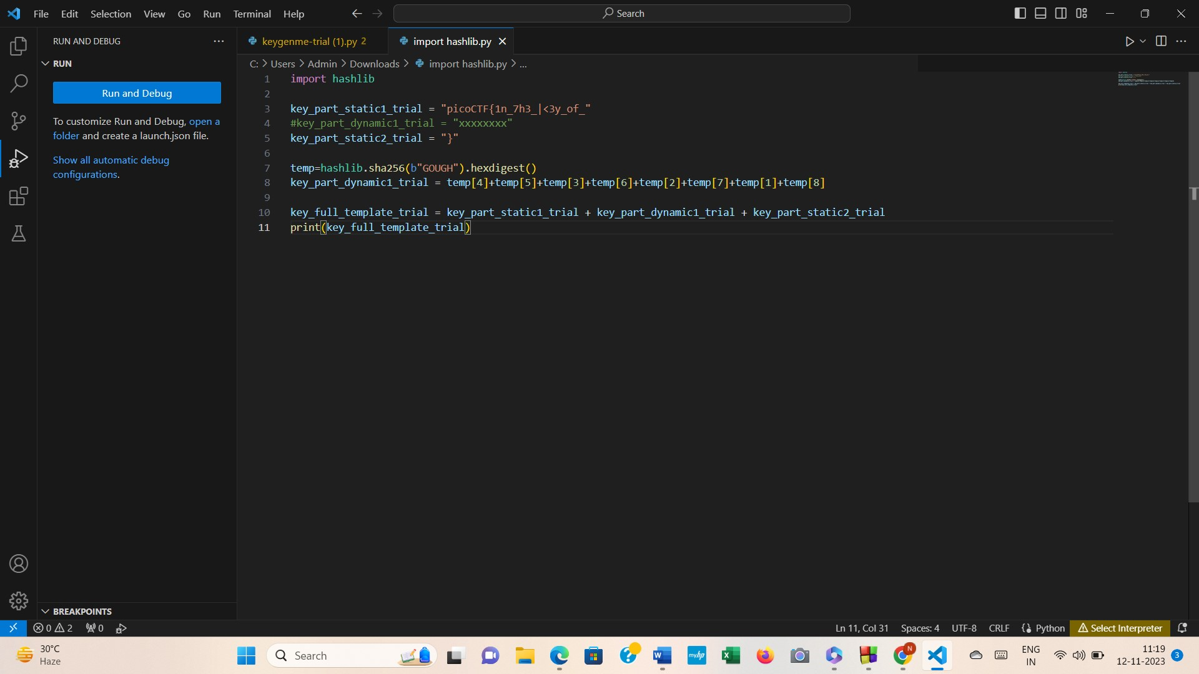

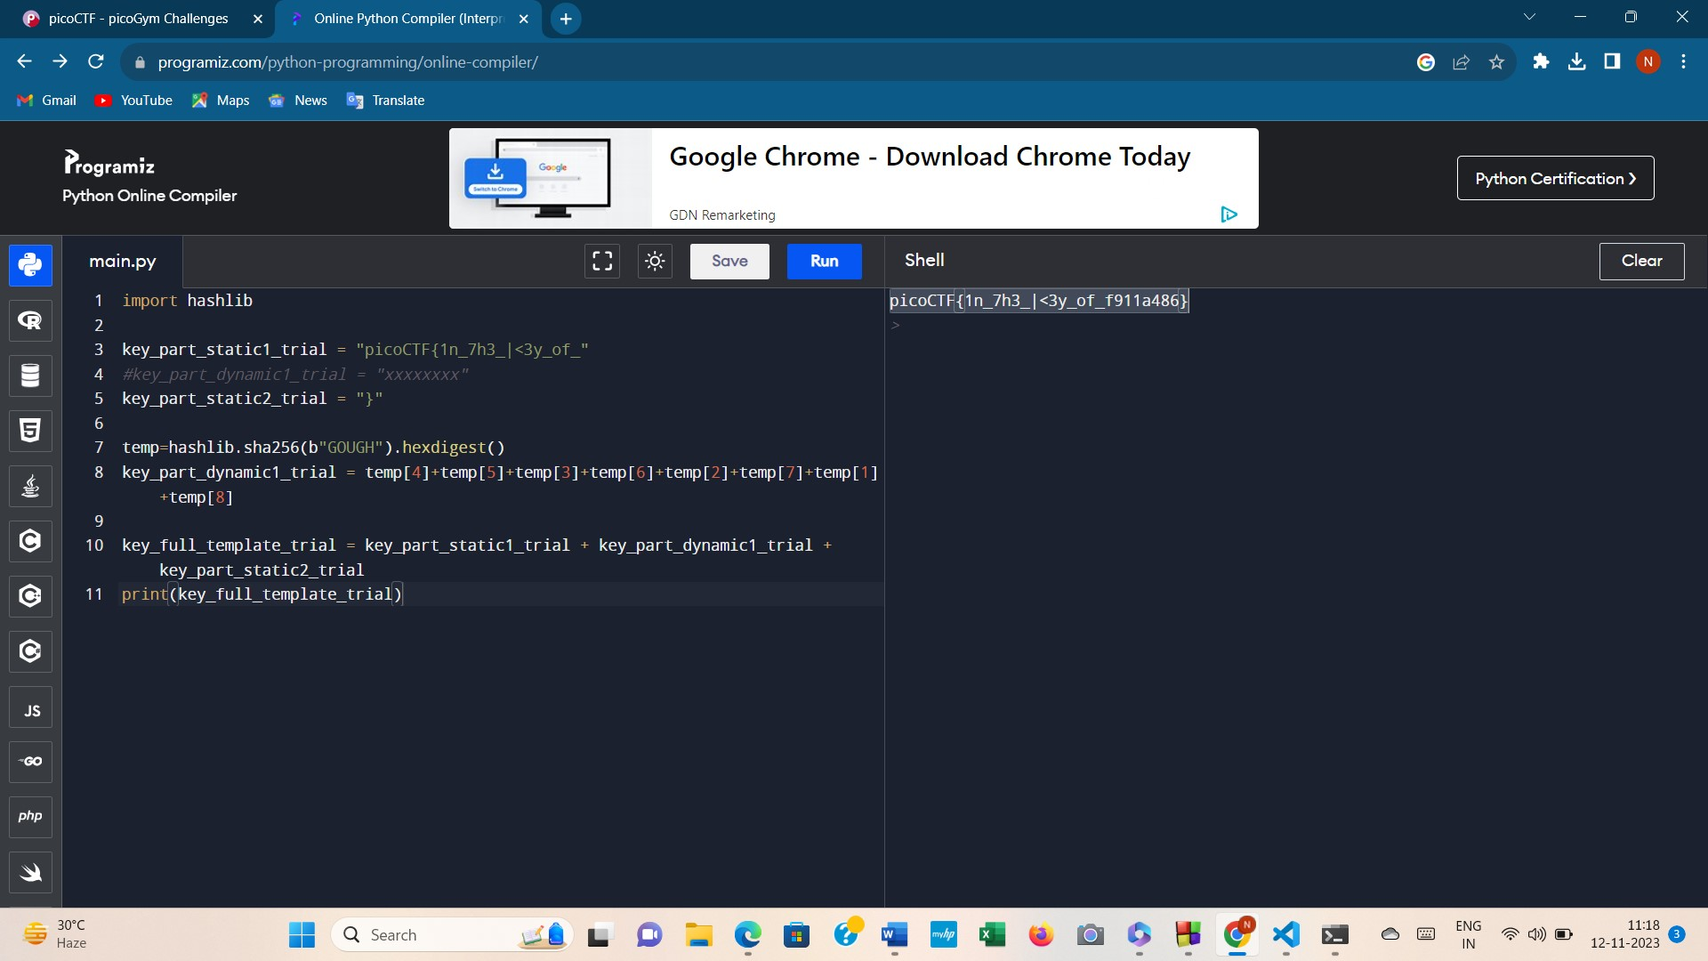

Buffer overflow

The program was given and link to its source was also provided. Initially I checked the file type ; since it was a binary exploitation challenge the file was a binary file.So here in order to smash the file we need use bunch of some characters .Here on using ‘A’s I was able to crack it.

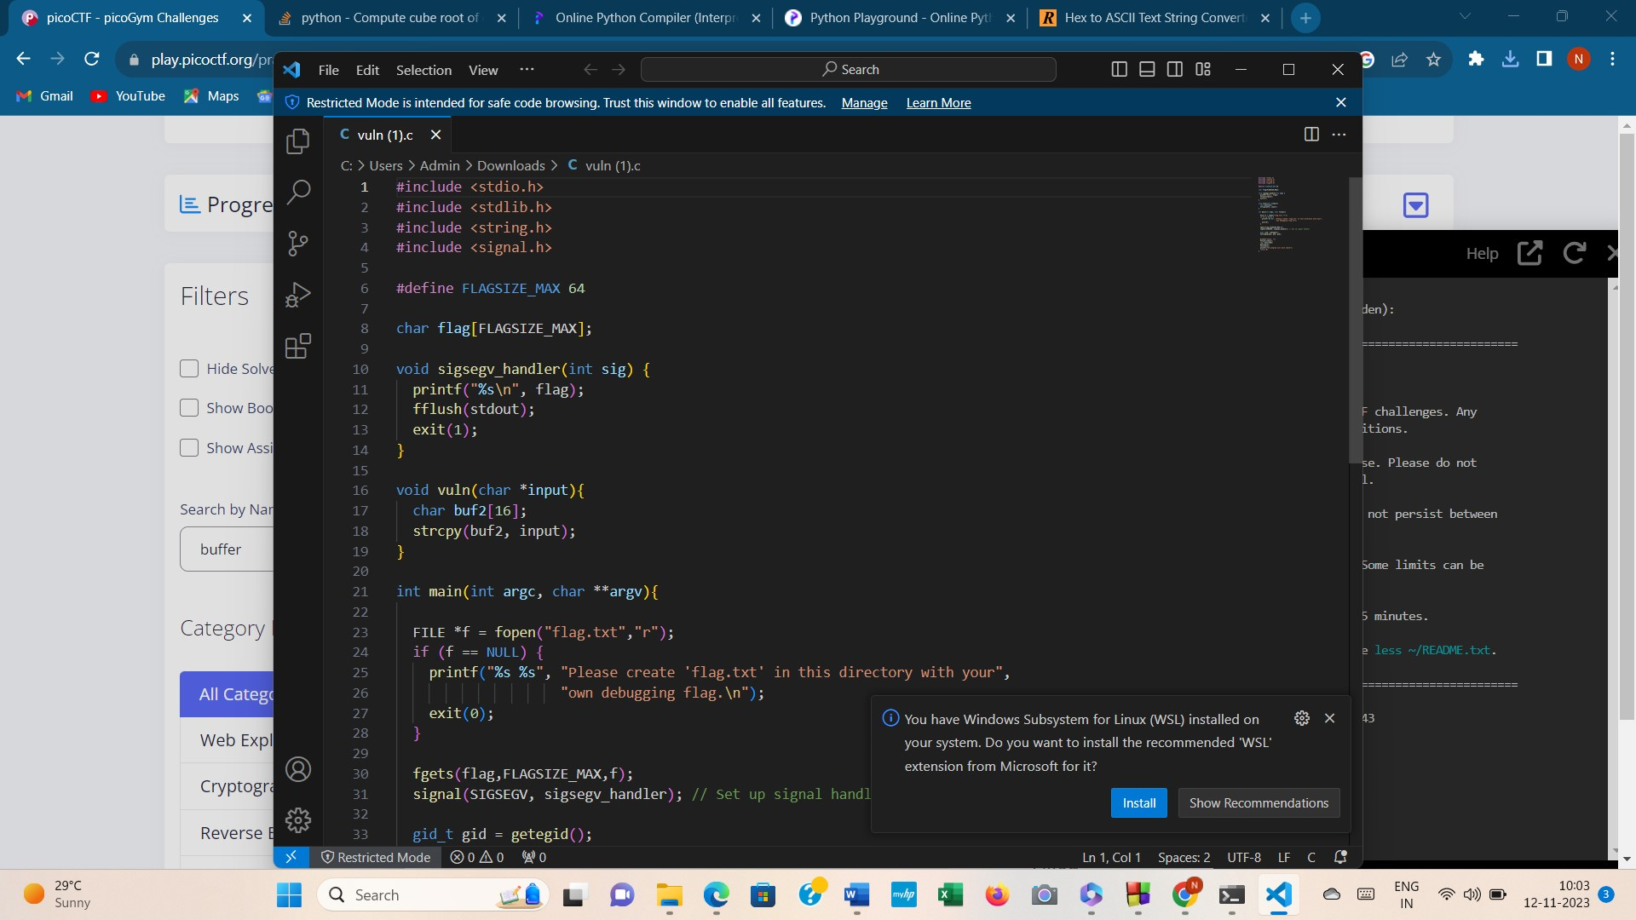

Basic mod1

“We found this weird message being passed around on the servers, we think we have a working decryption scheme.

Download the message here.

Take each number mod 37 and map it to the following character set: 0-25 is the alphabet (uppercase), 26-35 are the decimal digits, and 36 is an underscore.

Wrap your decrypted message in the picoCTF flag format” was the description

On opening the message file, I received a series of numbers as shown below

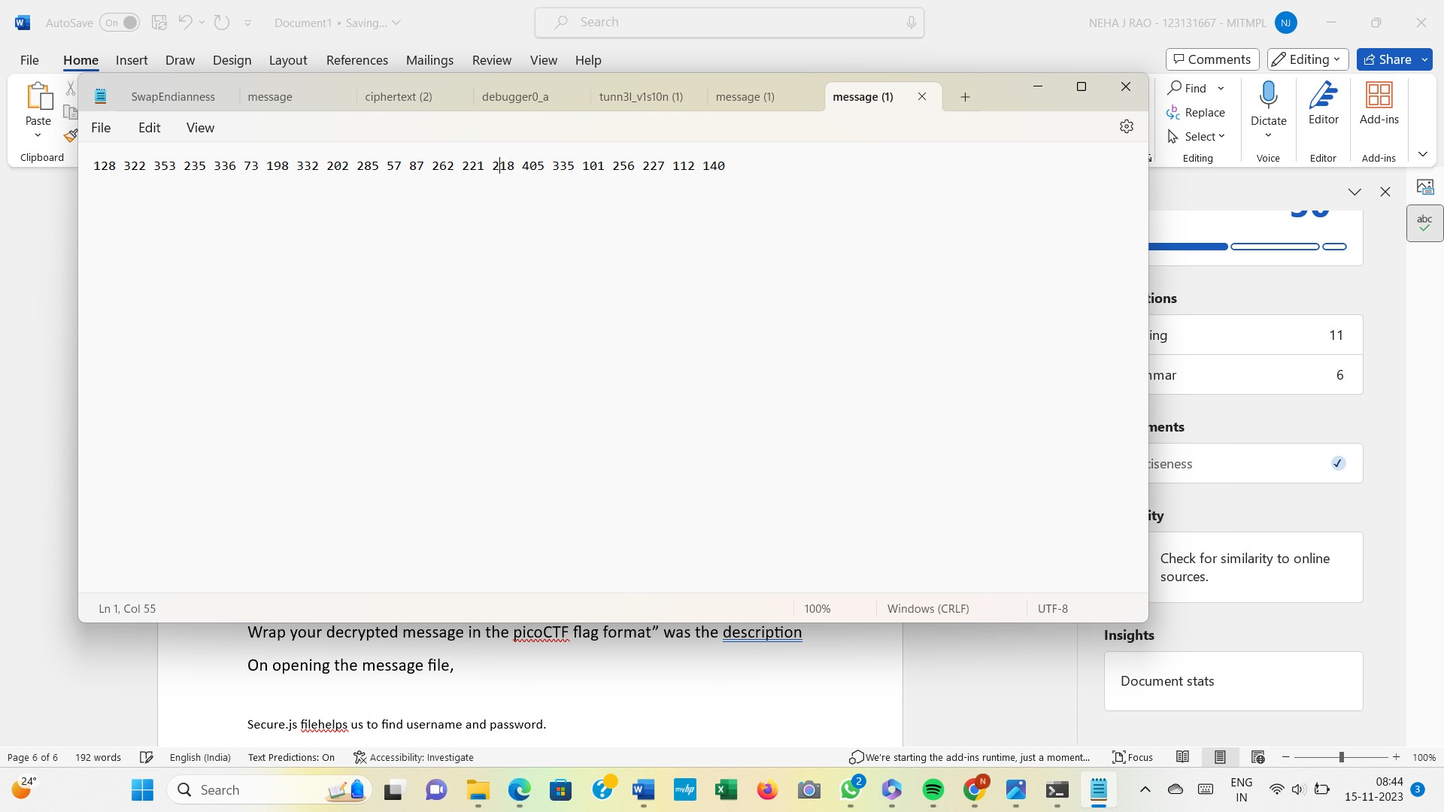

Then I created a python file to display the FLAG. The code was successful and I got the flag.The steps ,which I have followed is shown below:

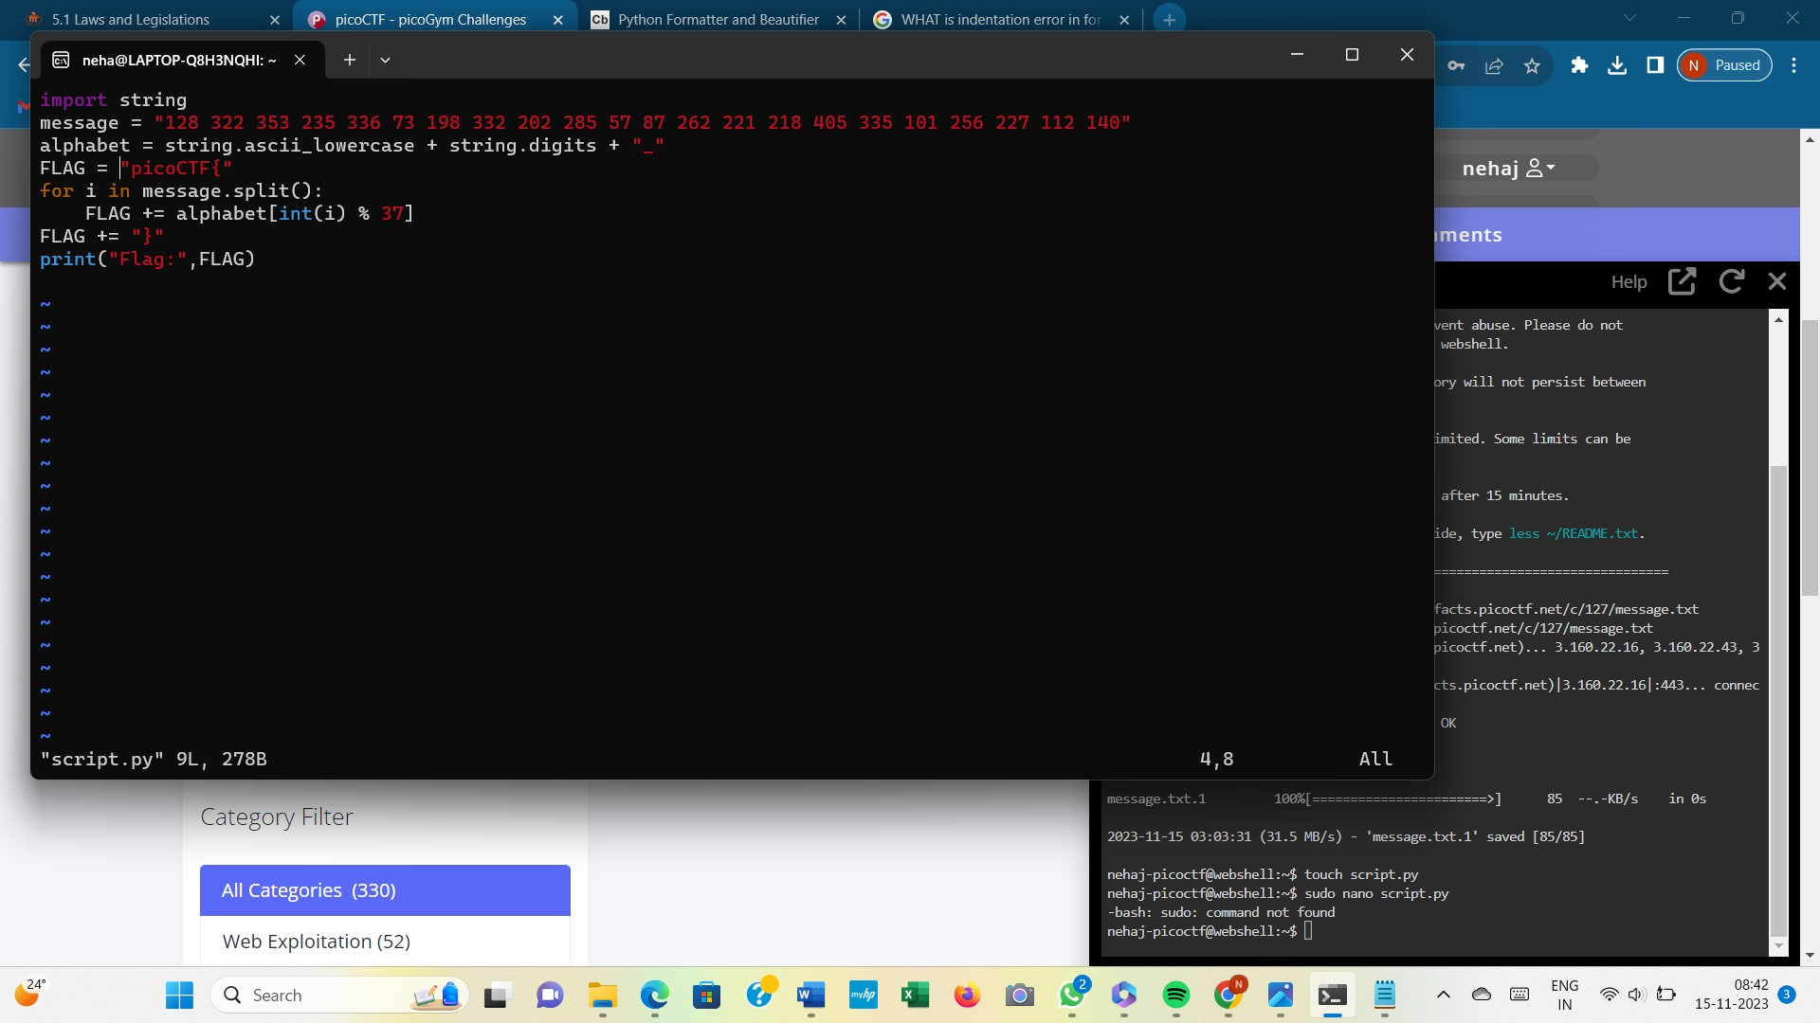

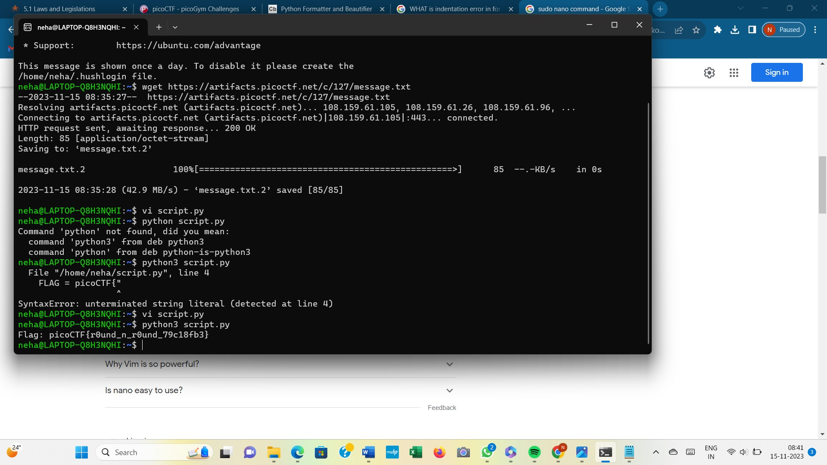

LOCAL AUTHORITY

This challenge comes under the category of WEB EXPLOITATION, and it was quite easy. We were provided with the link to a particular website <http://saturn.picoctf.net:59126/> .The website asked us to provide username and password .But we don’t have any, So I opened the source code and noticed that it was in the HTML format later typed the same link using .php extension which gave me access to the source code. The code contains access to a file named “Secure.js” .This file helps us to find username and password.Using the password provided we can easily login and get the flag.I have also attached screenshots for above mentioned explanation.

